# TRACING THE GROWTH OF THE GLOBAL COMMUNITY: A POPULATION FORECASTING ANALYSIS.

# 1.INTRODUCTION

# 1.1.OVERVIEW

Demography is defined as the scientific study of population. It covers five basic topics ;the size of the population; its distribution across geographic areas; its composition (eg.,sex,age,race and other characteristics); changes in population size ,distribution, and composition over time; and the determinants and consequence of the population growth. We define some commonly used terms describe a number of statistical measures , and discuss several sources of democratic data. This will give readers with little training or experience in demography in brief introduction to the field and set the stage for the topics covered in the remainder.

# 1.2.PURPOSE

Demography is the statistical description and analysis of the human population. It refers to ascertaining the number and distribution of people , changes in the umber and distribution of people over time, age and sex composition , birth and death among various quantity of population .

Study of population seeks to discover the causes and consequence of population changes. The changes in population take place premirely due to changes in birth and death and migration which are reffered to as the three components of population changes. As an interplay of these three components one looks at the number of total person which is usually refered to as size; the characteristics of population, called compositions; and whereare these people located labeled as distribution of the population. prior to the discussion of the significance of the study of population it seems pertinent to explain some of the basic concepts likely to be used in this course.

To analyse about the growth of the global community we have created the collected datas iinto visualization, dashboard and stories.

# 2. PROBLEM DEFINITION AND DESIGN THINKING

# 2.1 EMPATHY MAP

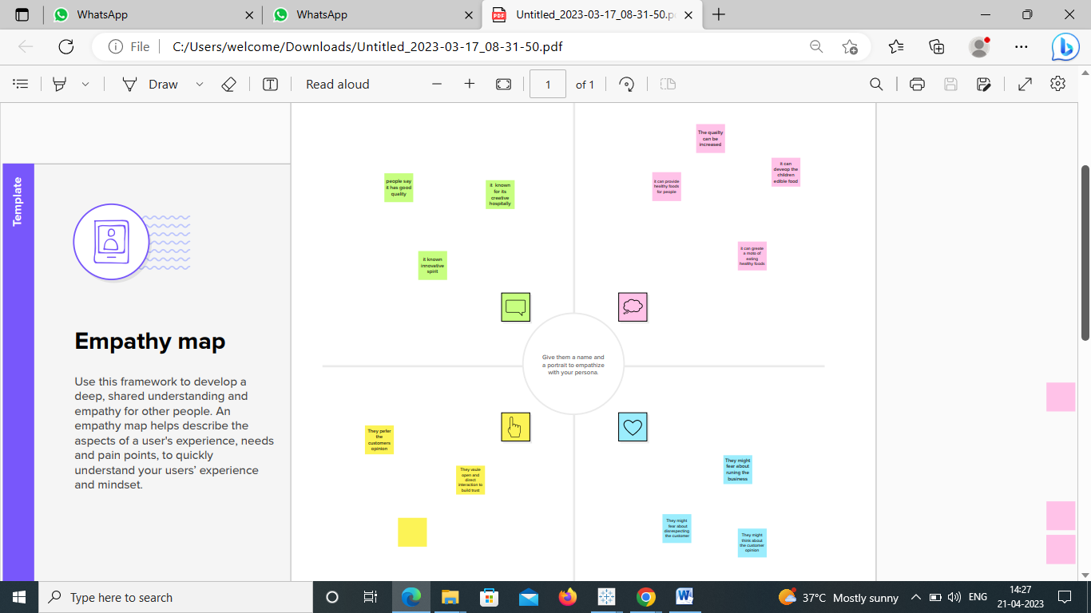

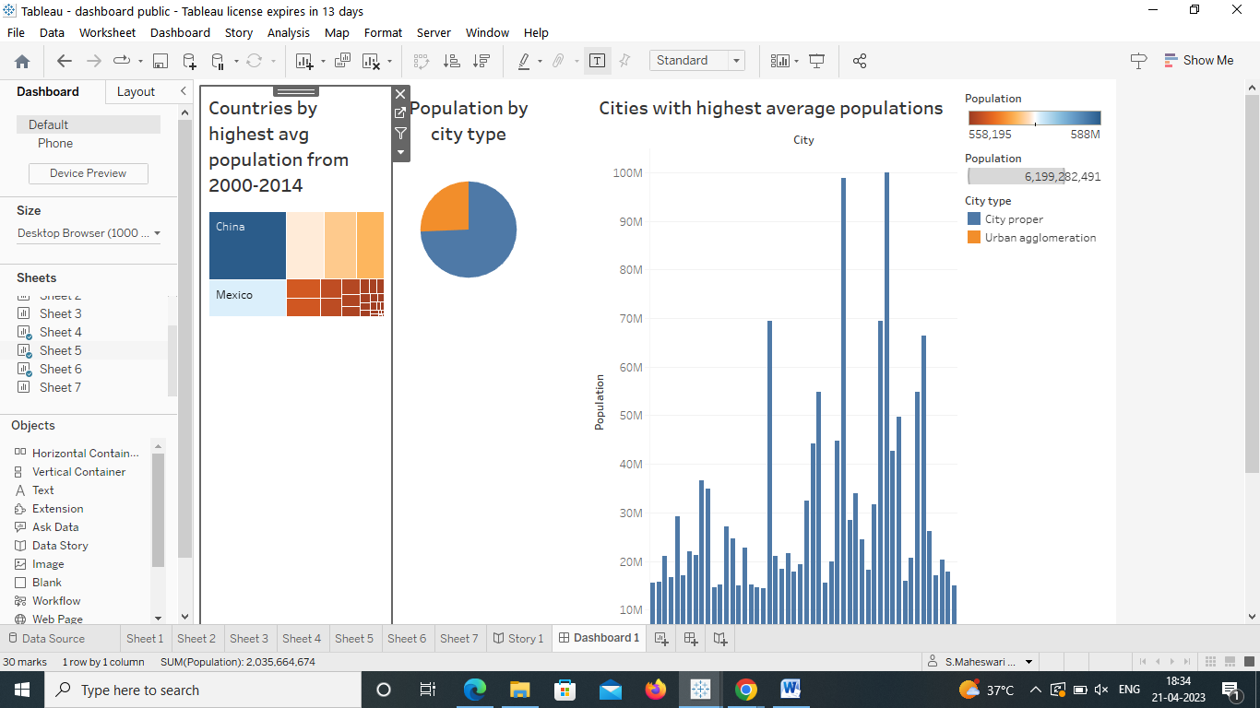

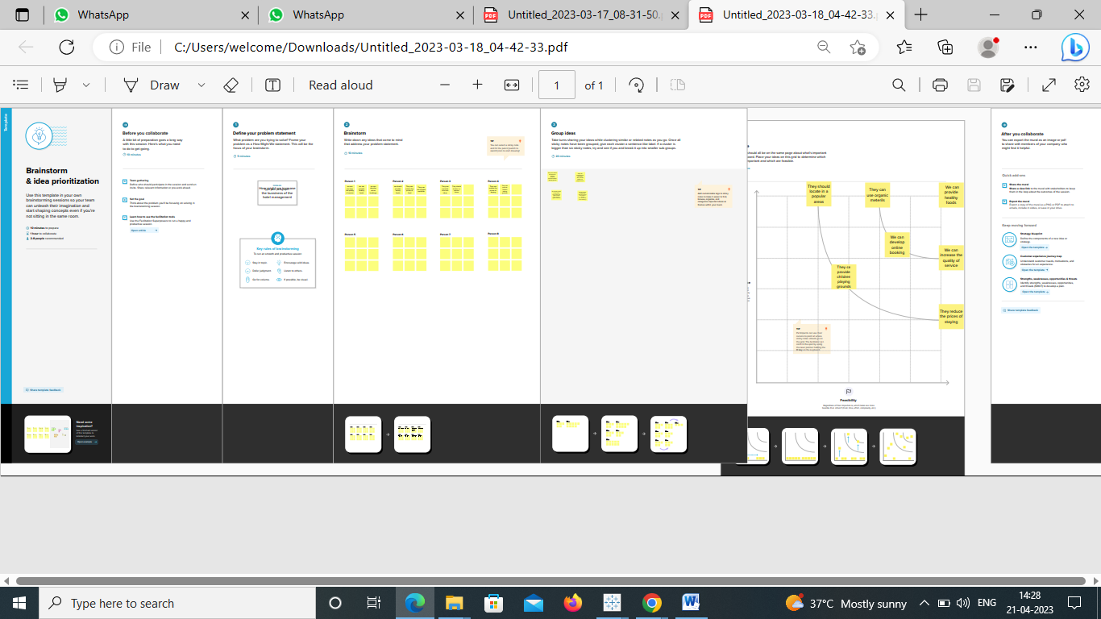

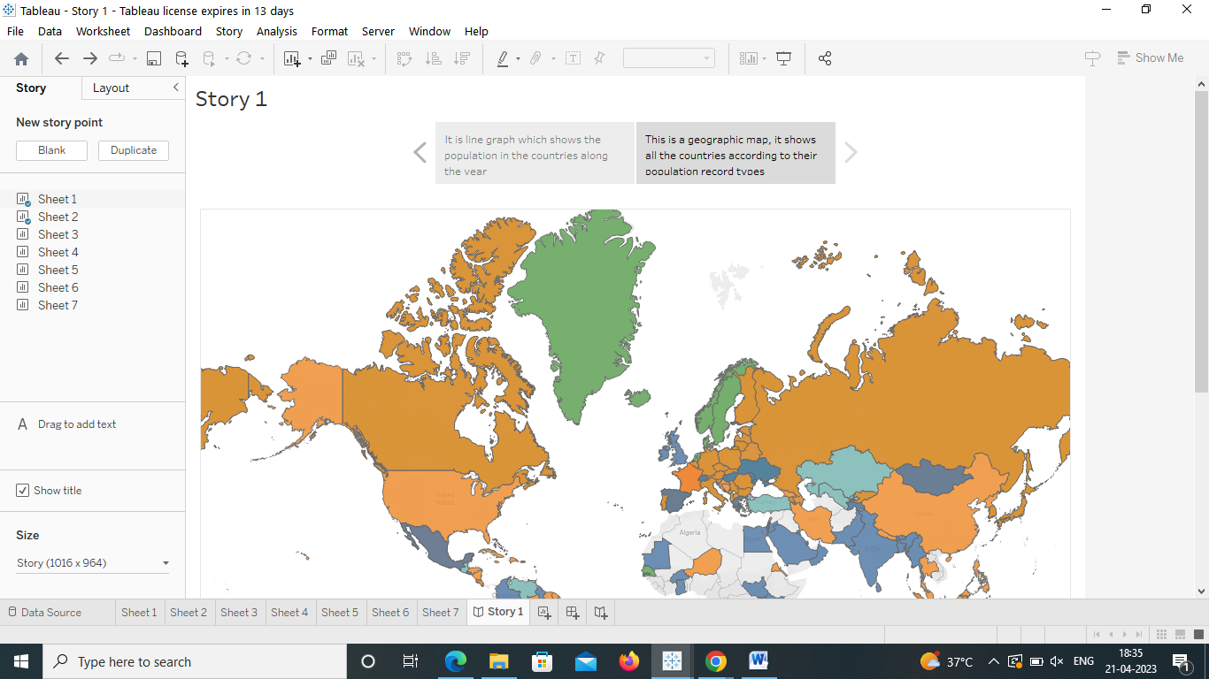

**4 ADVANTAGES AND DISADVANTAGES**

# ADVANTAGES

The population is declining in many western economies, which has led to a skewing of the population toward the elderly and retired. We are struggling to pay for health care & pensions, which is placing costs on society. Moderate population increase contributes to rebalancing the population by increasing the proportion of young, working adults.

There will be greater demand for some industries in a nation with a higher population. As long as it can produce enough of an item or service to satisfy demand, a company that sells it will experience great success.

If a country can administer its huge population, it can have a significant military advantage compared to smaller ones. The size of the military will increase, as will the number of military supplies if the economy remains stable and the government can successfully handle the nation's expanding population.

Additionally, a population increase may stimulate technological advancement that would enable the production of more sophisticated military products.

# DISADVANTAGES

Demand for resources rises as the population grows. Resources, however, are in infinite quantity; thus, this is an issue because if a large number of people utilize them, they'll run out and become scarce, resulting in poverty.

More people means more people to feed, which strains food availability. As a result, food shortages are common in developing countries with quickly growing populations. They cannot feed their expanding population despite their efforts to raise agricultural output.

The World Health Organization (WHO) asserts that areas with high population densities may see fewer disease outbreaks and lower infection rates. It is much simpler for germs and viruses to move from person to person when so many people live close to one another.

To boost capital production, developing countries manage the population composition. Due to the high birth rate & short life expectancy, these countries have comparatively high dependency rates. Rapid population growth in emerging countries reduces the quantity of capital accessible per person, which lowers the workforce's productivity. As a result, their income decreases, and they are less able to save money, negatively affecting capital formation.

A fast-expanding population means that a sizable number of individuals will join the labor force, many of whom may be unable to find employment. The number of job seekers is increasing so quickly in developing countries that it will be difficult to employ everyone despite all attempts to promote planned growth. These countries frequently experience underemployment, unemployment, and covert employment. The rapid increase in the global population makes it practically impossible for economically developing nations to address their unemployment issues.

# APPLICATION

Demographic analysis is needed in all stages of the planning process for both new and revised plans. Population analysis is needed to identify problems and community needs, establish goals and objectives, assess alternative courses of action, allocate resources for plan implementation, and evaluate the ability of the plan to achieve goals and objectives.

Determining How Many Children Will Need Immunizations

The cohort component method uses age-specific fertility rates to determine the number of expected births that will occur during the projection period. This information can be useful in determining the expected number of new children that will require immunizations. These projections can be calculated for all districts.

Estimating Resources Needs

The cohort component projection provides information on the future number of children under age 5 for each district. Projections of the expected number of children under age 5, along with information on existing staff, medicine, clinics, and other available resources, will help the Ministry of Health allocate resources among the districts.

Land Use Planner: Capital City

In this case study the city planning agency is concerned about the impact of population growth and change on its ability to implement its urban land use plan. These plans are usually developed to guide the physical, social and economic development of a city for a 20-year period. The plan guides decisions concerning residential, commercial, industrial and recreational uses of land. These plans also guide decisions concerning the spatial location of infrastructure such as public water and sewer facilities, roads and public transportation, and community facilities such as schools, parks, health clinics and hospitals, and fire and police protection.

Types of population information

To understand the impact of population change on implementing the comprehensive, the planner must study past, current and future population trends. This includes changes in the current and future size of the population as well as changes in the composition of the population.

Examining changes in the composition

The unit of analysis is the census tract or other unit of geographic measurement within the city. The planner wants to know where growth or decline is taking and among which segments of the population. Maps are needed to spatially indicate changing demographic characteristics in the city. Analysis of the composition includes an investigation into the age and sex structure, occupation, education, income, ethnicity, and household structure and size. The planners may also wish to examine changes in the housing characteristics in the city to determine where the quality of housing has increased or decreased. The census of housing can help planners revised housing strategies and infrastructure plans.

The population analysis can help the planner make recommendations on whether the agency should revise the goals and objectives and planned programs of the plan. The analysis can also support recommendations for the best physical locations to allocate expand services.

# CONCLUSION

This chapter reviews the various assessments of the size of India’s population that have emerged in the book. It also comments briefly on some general issues. These issues include: the matter of past fluctuations in the size of the population and how they may—or may not—have been related to changes in the resource base; the degree to which trends in India’s population may—or may not—have corresponded to the population trends that were common to both Europe and China; the existence and influence of different demographic regimes; and the question of why before the nineteenth century there is such a chronic scarcity of data relating to India’s population.

# FUTURE SCOPE

The UN Population Division report of 2022 projects world population to continue growing after 2050, although at a steadily decreasing rate, to peak at 10.4 billion in 2086, and then to start a slow decline to about 10.3 billion in 2100 with a growth rate at that time of -0.1%.

